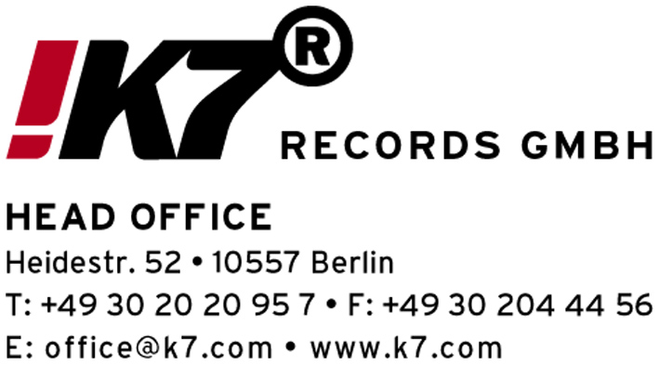

DADDY G (Massive Attack) – “DJ-Kicks“ (!K7170 CD/LP)
(release date: October 18th 2004)

You may consider Grant Marshall, a.k.a. Daddy G as spiritus rector of what has historically become known as the "Bristol Sound“. It´s that laid back sound that breathes dub, reggae, funk, disco and hip hop, represented by protagonists like Massive Attack, Smith & Mighty, Tricky and Portishead. A sound that left its global traces for more than one and a half decades. And Daddy G is its spiritus rector because he was one of the founders of the Wild Bunch Sound System, out of which later Massive Attack emerged. Besides Mushroom and 3-D, Daddy G was both one of the core members of the group as well as one of the group´s main voices.
Way before being part of a band though, Daddy G was known as a DJ. As a ten year old he already recorded mix tapes, inspired by the DJ boyfriend of his older sister. 1980 he was one of the youngest Bristol DJs, quickly establishing his name as a synonym for an eclectic music style. At the parties at which G played, one could always hear the newest in disco, fresh punk funk from NY, the first rap imports as well as soul and dub reggae. When the Wild Bunch Sound System was founded, Daddy G already was a local celebrity. His DJ sets were not only legendary because of their selection and his mixing skills, but because he rocked the microphone as versatile as the wheels of steel.
For his mix for the newest installment of the "DJ-Kicks“ series, Daddy G dug deep in his record case. "Rock steady baby," sings Aretha Franklin on the penultimate cut of this mix. Rocksteady, of course, was also a Jamaican style of the late 1970s, essentially a kind of slowed-down ska. For Daddy G, reggae is the source. This mix kicks off with two tracks from the legendary Studio One stable, including his "most favourite record ever", Willie Williams' 'Armagideon Time', and proceeds with 'Non Non Non' by Melaaz, a languid French version of a Studio One classic. Barrington Levy's 'Here I Come' is a dancehall classic, Foxy Brown's sassy 'Oh Yeah' is based on an old Toots & the Maytals tune, and Johnny Osbourne's 'Budy Bye' is an early slice of electronic reggae.
The Meters are included with a song for Daddy G's daughter, Ava. That and Aretha's 'Rock Steady' square the reggae-soul circle, the latter in the shape of Danny Krivit's inspirational but extremely hard-to-find edit. This isn't the only rarety on the mix. 'Aftermath' comes in Tricky's original white label version. 'I Against I' was recorded by Massive Attack with Mos Def for the Blade 2 soundtrack and never released anywhere else. Badmarsh and Shri's 'Signs' appears, like several other tracks, in limited edition dubplate form.
It´s obvious that Daddy G included many tracks by his original crew, Massive Attack: Apart from 'I Against I' and a rare mix of 'Karmacoma', Daddy G has also included their groundbreaking remixes of Les Negresses Vertes and Nusrat Fateh Ali Khan ("the most enjoyable mix we've ever done"), finally ending up with Paul Oakenfold's subtle mix of 'Unfinished Sympathy'.
There are DJs, that get their kicks from playing out obscure white labels that no one knows. And then there´s DJs who simply enjoy playing their favourite records. Daddy G belongs to the latter. On his mix for the DJ-Kicks series he simply says: "These tracks are always in my box.“

TRACK LISTING:

 | Artist | Title | Version | Label
1 | Intro (by Philip Levi & Tipper Irie)
2 | Willie Williams | Armagideon Time |  | Soul Jazz Records
3 | Sound Dimension | Rockfort Rock |  | Soul Jazz Records
4 | Melaaz | Non Non Non |  | Melaaz
5 | Tricky | Aftermath | Version 1 | Universal
6 | Meters | Just Kissed My Baby |  | Warner
7 | Nusrat Fateh Ali Khan | Mustt Mustt | Massive Attack Remix | EMI
8 | Les Negresses Vertes | Face A La Mer | Massive Attack Remix | EMI
9 | Massive Attack | Karmacoma | The Napoli Trip | EMI
10 | Johnny Osbourne | Budy Bye |  | King Jammys
11 | Badmarsh & Shri | Signs | Dublate Mix | Outcaste Records
12 | Barrington Levy | Here I Come | Dublate Version | Greensleeves
13 | Foxy Brown | Oh Yeah |  | Universal
14 | Leftfield | Inspection/ Check One |  | Sony
15 | Massive Attack And Mos Def | I Against I |  | Virgin
16 | Aretha Franklin | Rock Steady | Danny Krivit Edit | Warner
17 | Massive Attack | Unfinished Sympathy | Perfecto Mix by Paul Oakenfold | EMI

